Online Supplementary Material
Kappelmann et al. & Arloth. Predicting Treatment Outcome in Depression using Multi-Omics Immunophenotyping and Machine Learning

Table of Contents
Methods 2
Statistical Analysis 2
Online Supplementary Table 1: Symptom Availability and Coding Across Samples 2
Shrinkage parameters 4
Online Supplementary Table 2: Shrinkage Parameters for CRP 4
Results 5
Online Supplementary Table 2: SNP Inclusion across PRSs and Samples 5
Online Supplementary Table 2: SNP Overlap with GWAS Summary Statistics 6
Online Supplementary Table 5: MARS MDS Outlier Removal 7

Methods

Study Population
The OPTIMA study started in 2017 and is an ongoing, single-centre, naturalistic randomised controlled trial (RCT) evaluating comparative effectiveness of schema therapy, cognitive behavioural therapy, and individual supportive therapy as treatment for depression (Kopf-Beck et al., 2020). Study participants included patients who were admitted to day clinic or inpatient wards of the Max Planck Institute of Psychiatry in Munich and who were diagnosed with moderate-to-severe Major Depressive Disorder (MDD) without psychotic symptoms, as assessed by the treating physician. In addition to MDD diagnosis, inclusion criteria for the study were a score of at least 20 on Montgomery-Åsberg Depression Rating Scale (MADRS) or Beck Depression Inventory (BDI)-II (Beck, Steer, & Brown, 1996; Montgomery & Asberg, 1979); age 18-75 years; and informed consent (given prior to participation). Exclusion criteria were acute suicidality; lifetime history of psychotic or bipolar disorder; history of, or current, severe neurological or internal physical disease; IQ<80 or severe learning disability; current substance use or withdrawal syndrome; severe mutism or stupor; MDD secondary to any physical illness; pregnancy or lactation period; and German language proficiency considered insufficient for psychotherapeutic treatment.
The study duration included a baseline week with various assessments followed by 7-week psychotherapeutic treatment. Antidepressant medication (ADM) was given throughout the stay at the clinic as were additional therapies such as sports and/or occupational therapy.

Cytokine Measurements
tbc

Statistical Analysis
tbc

Results

Online Supplementary Table 1: Cytokine Descriptive Statistics
 | Inflammation Status
Variable | Non-Inflamed | Inflamed | Pª | Total
N | 74 (64.9%) | 40 (35.1%) | - | 114 (100%)
hsCRP
Mean (SD) | -0.31 (0.77) | 0.56 (0.62) |  | 0 (0.83)
Median (IQR) | -0.21 (-0.64-0.22) | 0.65 (0.04-0.99) | <0.001 | 0.02 (-0.52-0.58)
Missing (%) | 0 (0%) | 0 (0%) |  | 0 (0%)
Eotaxin-3
Mean (SD) | 0.11 (0.97) | 0.06 (1.02) |  | 0.1 (0.99)
Median (IQR) | 0.08 (-0.53-0.7) | 0.16 (-0.65-0.64) | 0.776 | 0.11 (-0.56-0.7)
Missing (%) | 0 (0%) | 0 (0%) |  | 0 (0%)
GM-CSF
Mean (SD) | -0.01 (0.9) | 0.08 (1.08) |  | 0.02 (0.97)
Median (IQR) | 0.01 (-0.67-0.76) | 0.17 (-0.57-0.84) | 0.709 | 0.14 (-0.62-0.8)
Missing (%) | 33 (44.59%) | 12 (30%) |  | 45 (39.47%)
IL-31
Mean (SD) | 0.25 (0.86) | 0.27 (0.95) |  | 0.26 (0.89)
Median (IQR) | 0.21 (-0.33-0.89) | 0.18 (-0.3-0.82) | 0.932 | 0.21 (-0.33-0.87)
Missing (%) | 2 (2.7%) | 4 (10%) |  | 6 (5.26%)
TARC
Mean (SD) | 0.15 (0.99) | 0.4 (1.05) |  | 0.24 (1.01)
Median (IQR) | 0.1 (-0.51-0.82) | 0.51 (-0.05-1.03) | 0.213 | 0.26 (-0.36-0.9)
Missing (%) | 0 (0%) | 0 (0%) |  | 0 (0%)
IFN-gamma
Mean (SD) | 0.06 (0.89) | 0.12 (1) |  | 0.08 (0.93)
Median (IQR) | 0.01 (-0.49-0.65) | 0.21 (-0.65-0.73) | 0.721 | 0.08 (-0.55-0.68)
Missing (%) | 0 (0%) | 0 (0%) |  | 0 (0%)
VEGF-A HS
Mean (SD) | -0.1 (0.78) | 0.66 (0.79) |  | 0.17 (0.86)
Median (IQR) | -0.05 (-0.65-0.3) | 0.76 (0.13-1.17) | <0.001 | 0.16 (-0.31-0.77)
Missing (%) | 0 (0%) | 0 (0%) |  | 0 (0%)
MDC
Mean (SD) | 0.21 (1.04) | 0.55 (1.12) |  | 0.33 (1.08)
Median (IQR) | 0.24 (-0.53-0.98) | 0.75 (0.17-1.23) | 0.11 | 0.48 (-0.32-1.12)
Missing (%) | 0 (0%) | 0 (0%) |  | 0 (0%)
TNF-beta
Mean (SD) | 0.3 (0.96) | -0.08 (0.84) |  | 0.17 (0.93)
Median (IQR) | 0.31 (-0.09-0.86) | -0.2 (-0.59-0.46) | 0.051 | 0.22 (-0.42-0.73)
Missing (%) | 6 (8.11%) | 5 (12.5%) |  | 11 (9.65%)
MCP-4
Mean (SD) | 0.25 (0.98) | 0.43 (0.88) |  | 0.31 (0.94)
Median (IQR) | 0.23 (-0.36-0.87) | 0.53 (-0.08-1.01) | 0.311 | 0.38 (-0.3-0.96)
Missing (%) | 0 (0%) | 0 (0%) |  | 0 (0%)
SAA
Mean (SD) | -0.4 (0.71) | 0.64 (0.84) |  | -0.04 (0.9)
Median (IQR) | -0.34 (-0.89-0.11) | 0.67 (0.02-1.14) | <0.001 | -0.06 (-0.6-0.48)
Missing (%) | 0 (0%) | 0 (0%) |  | 0 (0%)
IL-10
Mean (SD) | 0.22 (1.06) | -0.01 (1.01) |  | 0.14 (1.04)
Median (IQR) | 0.25 (-0.52-1.03) | -0.01 (-0.56-0.67) | 0.283 | 0.1 (-0.53-0.95)
Missing (%) | 0 (0%) | 0 (0%) |  | 0 (0%)
IL-16
Mean (SD) | -0.05 (0.89) | 0.37 (1.02) |  | 0.09 (0.95)
Median (IQR) | -0.03 (-0.6-0.6) | 0.41 (-0.15-1.05) | 0.023 | 0.1 (-0.55-0.77)
Missing (%) | 0 (0%) | 0 (0%) |  | 0 (0%)
MIP-1beta
Mean (SD) | 0.23 (0.91) | 0.48 (1) |  | 0.32 (0.94)
Median (IQR) | 0.21 (-0.39-0.84) | 0.43 (-0.27-1.08) | 0.193 | 0.3 (-0.31-0.96)
Missing (%) | 0 (0%) | 0 (0%) |  | 0 (0%)
VEGF-D
Mean (SD) | -0.16 (0.9) | -0.11 (1.04) |  | -0.14 (0.95)
Median (IQR) | -0.12 (-0.67-0.5) | -0.14 (-0.89-0.49) | 0.786 | -0.14 (-0.75-0.5)
Missing (%) | 0 (0%) | 0 (0%) |  | 0 (0%)
IL-6
Mean (SD) | -0.13 (0.81) | 0.89 (0.8) |  | 0.28 (0.95)
Median (IQR) | -0.07 (-0.7-0.43) | 0.94 (0.46-1.33) | <0.001 | 0.35 (-0.31-0.92)
Missing (%) | 16 (21.62%) | 0 (0%) |  | 16 (14.04%)
Flt-1
Mean (SD) | -0.09 (1.09) | 0.34 (1.07) |  | 0.06 (1.1)
Median (IQR) | 0.11 (-0.68-0.59) | 0.39 (-0.41-1.16) | 0.045 | 0.17 (-0.58-0.82)
Missing (%) | 0 (0%) | 0 (0%) |  | 0 (0%)
IL-22
Mean (SD) | -0.02 (0.82) | 0.26 (1.02) |  | 0.09 (0.91)
Median (IQR) | -0.15 (-0.68-0.43) | 0.23 (-0.45-0.91) | 0.177 | 0.05 (-0.61-0.68)
Missing (%) | 25 (33.78%) | 10 (25%) |  | 35 (30.7%)
PlGF
Mean (SD) | 0.37 (0.79) | 0.88 (0.94) |  | 0.55 (0.88)
Median (IQR) | 0.36 (-0.18-0.9) | 0.87 (0.42-1.53) | 0.003 | 0.56 (0-1.16)
Missing (%) | 0 (0%) | 0 (0%) |  | 0 (0%)
IP-10
Mean (SD) | 0.08 (1.06) | 0.36 (0.99) |  | 0.18 (1.04)
Median (IQR) | 0.18 (-0.53-0.87) | 0.47 (-0.49-1.14) | 0.181 | 0.29 (-0.52-1.01)
Missing (%) | 0 (0%) | 0 (0%) |  | 0 (0%)
IL-1alpha
Mean (SD) | -0.03 (0.91) | -0.04 (0.98) |  | -0.04 (0.93)
Median (IQR) | -0.12 (-0.55-0.56) | 0.02 (-0.75-0.49) | 0.961 | -0.05 (-0.66-0.54)
Missing (%) | 1 (1.35%) | 2 (5%) |  | 3 (2.63%)
IL-15
Mean (SD) | 0.16 (0.97) | 0.55 (1.01) |  | 0.3 (1)
Median (IQR) | 0.27 (-0.59-0.87) | 0.54 (-0.2-1.31) | 0.042 | 0.4 (-0.4-1.05)
Missing (%) | 0 (0%) | 0 (0%) |  | 0 (0%)
IL-12/IL-23p40
Mean (SD) | -0.04 (1.09) | 0.19 (1.05) |  | 0.04 (1.08)
Median (IQR) | -0.15 (-0.7-0.7) | 0.23 (-0.42-1) | 0.282 | -0.07 (-0.67-0.84)
Missing (%) | 0 (0%) | 0 (0%) |  | 0 (0%)
IL-17C
Mean (SD) | -0.01 (0.88) | 0.08 (1.12) |  | 0.02 (0.97)
Median (IQR) | 0.06 (-0.6-0.67) | 0.09 (-0.52-0.72) | 0.675 | 0.09 (-0.6-0.69)
Missing (%) | 14 (18.92%) | 8 (20%) |  | 22 (19.3%)
MIP-1alpha
Mean (SD) | 0.17 (0.93) | 0.44 (0.87) |  | 0.27 (0.91)
Median (IQR) | 0.12 (-0.61-0.85) | 0.48 (0.05-0.98) | 0.131 | 0.29 (-0.37-0.92)
Missing (%) | 3 (4.05%) | 1 (2.5%) |  | 4 (3.51%)
IL-27
Mean (SD) | 0.06 (1.01) | 0.04 (0.99) |  | 0.05 (1)
Median (IQR) | 0.12 (-0.76-0.83) | 0.02 (-0.69-0.73) | 0.901 | 0.11 (-0.72-0.77)
Missing (%) | 0 (0%) | 0 (0%) |  | 0 (0%)
IL-5
Mean (SD) | 0.07 (1.03) | 0.22 (1.04) |  | 0.13 (1.03)
Median (IQR) | 0.1 (-0.71-0.87) | 0.25 (-0.5-0.83) | 0.481 | 0.13 (-0.63-0.86)
Missing (%) | 10 (13.51%) | 2 (5%) |  | 12 (10.53%)
TSLP
Mean (SD) | 0.23 (0.89) | 0.47 (0.89) |  | 0.31 (0.9)
Median (IQR) | 0.31 (-0.34-0.85) | 0.53 (-0.06-1.08) | 0.173 | 0.38 (-0.32-0.96)
Missing (%) | 3 (4.05%) | 1 (2.5%) |  | 4 (3.51%)
CRP
Mean (SD) | -0.51 (0.66) | 1.23 (0.53) |  | 0.1 (1.03)
Median (IQR) | -0.41 (-0.98-0.04) | 1.17 (0.72-1.52) | <0.001 | 0.08 (-0.6-0.77)
Missing (%) | 0 (0%) | 0 (0%) |  | 0 (0%)
IL-12p70
Mean (SD) | 0.12 (0.93) | 0 (0.97) |  | 0.08 (0.94)
Median (IQR) | 0.1 (-0.48-0.79) | -0.2 (-0.64-0.78) | 0.503 | 0.01 (-0.56-0.79)
Missing (%) | 0 (0%) | 0 (0%) |  | 0 (0%)
bFGF
Mean (SD) | -0.26 (0.83) | -0.17 (0.88) |  | -0.23 (0.85)
Median (IQR) | -0.25 (-0.7-0.32) | 0.02 (-0.75-0.47) | 0.582 | -0.17 (-0.72-0.4)
Missing (%) | 1 (1.35%) | 0 (0%) |  | 1 (0.88%)
ICAM-1
Mean (SD) | -0.2 (1.05) | 0.65 (0.79) |  | 0.1 (1.05)
Median (IQR) | -0.1 (-0.99-0.5) | 0.57 (0.11-1.12) | <0.001 | 0.14 (-0.58-0.79)
Missing (%) | 0 (0%) | 0 (0%) |  | 0 (0%)
VEGF-C
Mean (SD) | -0.11 (0.96) | 0.23 (1.05) |  | 0.01 (1)
Median (IQR) | -0.08 (-0.76-0.49) | 0.4 (-0.67-0.95) | 0.102 | 0.05 (-0.74-0.68)
Missing (%) | 9 (12.16%) | 4 (10%) |  | 13 (11.4%)
VCAM-1
Mean (SD) | -0.04 (0.94) | 0.17 (0.93) |  | 0.03 (0.94)
Median (IQR) | 0.03 (-0.61-0.59) | 0.09 (-0.37-0.7) | 0.259 | 0.06 (-0.56-0.63)
Missing (%) | 0 (0%) | 0 (0%) |  | 0 (0%)
Eotaxin
Mean (SD) | 0.26 (0.91) | 0.08 (1.21) |  | 0.2 (1.02)
Median (IQR) | 0.41 (-0.44-0.94) | -0.21 (-0.78-1.13) | 0.383 | 0.3 (-0.58-0.98)
Missing (%) | 0 (0%) | 0 (0%) |  | 0 (0%)
IL-1RA
Mean (SD) | 0.1 (0.95) | 0.99 (0.9) |  | 0.41 (1.02)
Median (IQR) | 0.06 (-0.38-0.53) | 1.08 (0.64-1.58) | <0.001 | 0.38 (-0.25-1.09)
Missing (%) | 0 (0%) | 0 (0%) |  | 0 (0%)
IL-17A
Mean (SD) | 0.01 (1) | 0.23 (1.02) |  | 0.08 (1.01)
Median (IQR) | 0.02 (-0.58-0.54) | 0.33 (-0.57-1.03) | 0.279 | 0.1 (-0.59-0.75)
Missing (%) | 0 (0%) | 1 (2.5%) |  | 1 (0.88%)
IL-17B
Mean (SD) | 0.04 (0.92) | -0.09 (1.12) |  | -0.01 (1)
Median (IQR) | 0.07 (-0.77-0.68) | -0.09 (-0.95-0.7) | 0.531 | 0.02 (-0.78-0.7)
Missing (%) | 9 (12.16%) | 2 (5%) |  | 11 (9.65%)
IL-17D
Mean (SD) | 0 (0.89) | 0.04 (0.94) |  | 0.01 (0.91)
Median (IQR) | 0.06 (-0.58-0.58) | 0.05 (-0.7-0.66) | 0.836 | 0.06 (-0.63-0.64)
Missing (%) | 15 (20.27%) | 11 (27.5%) |  | 26 (22.81%)
IL-7
Mean (SD) | -0.11 (0.97) | 0.32 (0.94) |  | 0.04 (0.98)
Median (IQR) | -0.14 (-0.67-0.52) | 0.22 (-0.12-1.03) | 0.028 | 0.09 (-0.62-0.71)
Missing (%) | 2 (2.7%) | 1 (2.5%) |  | 3 (2.63%)
TNF-alpha
Mean (SD) | 0.22 (1) | 0.59 (0.91) |  | 0.35 (0.98)
Median (IQR) | 0.23 (-0.44-1) | 0.57 (-0.06-1.21) | 0.053 | 0.26 (-0.29-1.04)
Missing (%) | 0 (0%) | 0 (0%) |  | 0 (0%)
IL-8 HS
Mean (SD) | 0.21 (0.92) | 0.31 (0.92) |  | 0.25 (0.91)
Median (IQR) | 0.19 (-0.45-0.68) | 0.42 (-0.29-1.09) | 0.624 | 0.27 (-0.4-0.84)
Missing (%) | 12 (16.22%) | 5 (12.5%) |  | 17 (14.91%)
MCP-1
Mean (SD) | 0.07 (1.01) | 0.63 (0.97) |  | 0.27 (1.03)
Median (IQR) | 0.02 (-0.63-0.76) | 0.57 (-0.08-1.38) | 0.005 | 0.22 (-0.42-0.92)
Missing (%) | 0 (0%) | 0 (0%) |  | 0 (0%)
IL-2
Mean (SD) | -0.02 (0.98) | -0.21 (1.27) |  | -0.09 (1.09)
Median (IQR) | -0.09 (-0.71-0.67) | -0.22 (-0.89-0.65) | 0.391 | -0.11 (-0.79-0.67)
Missing (%) | 10 (13.51%) | 6 (15%) |  | 16 (14.04%)
VEGF-A LS
Mean (SD) | -0.17 (0.9) | 0.51 (0.85) |  | 0.07 (0.94)
Median (IQR) | -0.17 (-0.72-0.38) | 0.53 (-0.08-1.06) | <0.001 | 0.02 (-0.46-0.72)
Missing (%) | 0 (0%) | 0 (0%) |  | 0 (0%)
Tie-2
Mean (SD) | -0.08 (0.94) | -0.17 (1.09) |  | -0.11 (0.99)
Median (IQR) | -0.08 (-0.72-0.63) | -0.24 (-0.88-0.5) | 0.649 | -0.14 (-0.77-0.61)
Missing (%) | 0 (0%) | 0 (0%) |  | 0 (0%)
MIP-3alpha
Mean (SD) | -0.03 (0.95) | 0.05 (0.95) |  | 0 (0.95)
Median (IQR) | -0.04 (-0.63-0.56) | 0.03 (-0.64-0.81) | 0.712 | -0.03 (-0.64-0.66)
Missing (%) | 21 (28.38%) | 10 (25%) |  | 31 (27.19%)
Cortisol
Mean (SD) | 0.23 (0.9) | 0 (1.04) |  | 0.15 (0.95)
Median (IQR) | 0.17 (-0.22-0.88) | -0.24 (-0.79-0.83) | 0.233 | 0.07 (-0.42-0.85)
Missing (%) | 0 (0%) | 0 (0%) |  | 0 (0%)

Online Supplementary Table 2: Sample Size on Primary Outcome Scale over Time
Time (week) | 0 | 1 | 2 | 3 | 4 | 5 | 6 | 7
N | 114 | 94 | 87 | 89 | 91 | 75 | 72 | 79

Online Supplementary Figure 1: Cytokine Data Completeness
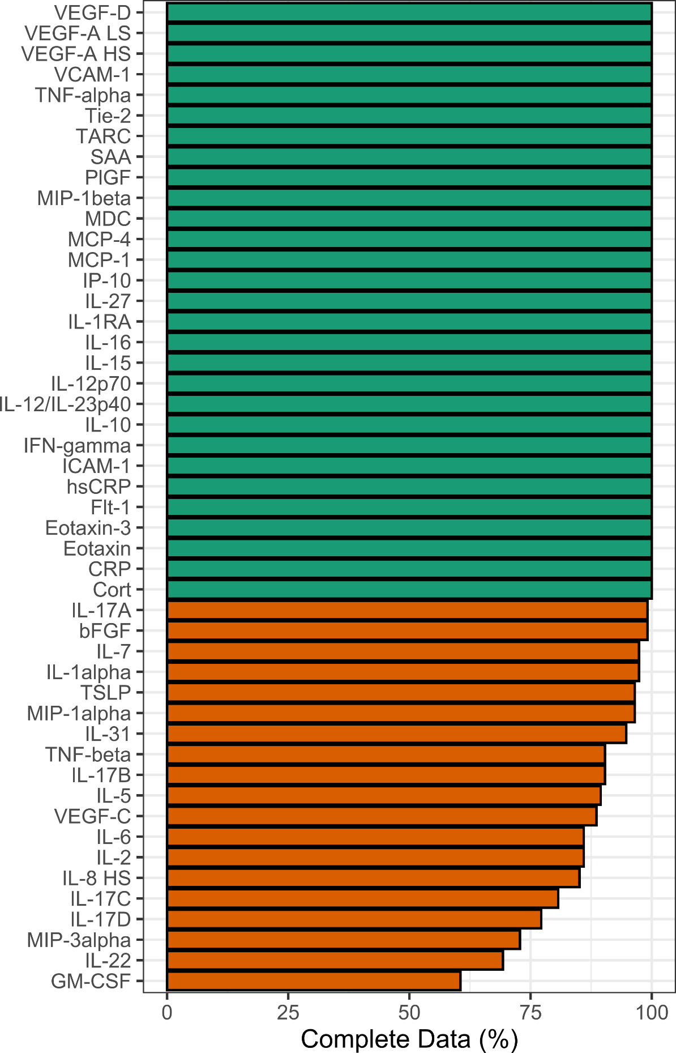

Online Supplementary Figure 2: Cytokine Correlation Matrix
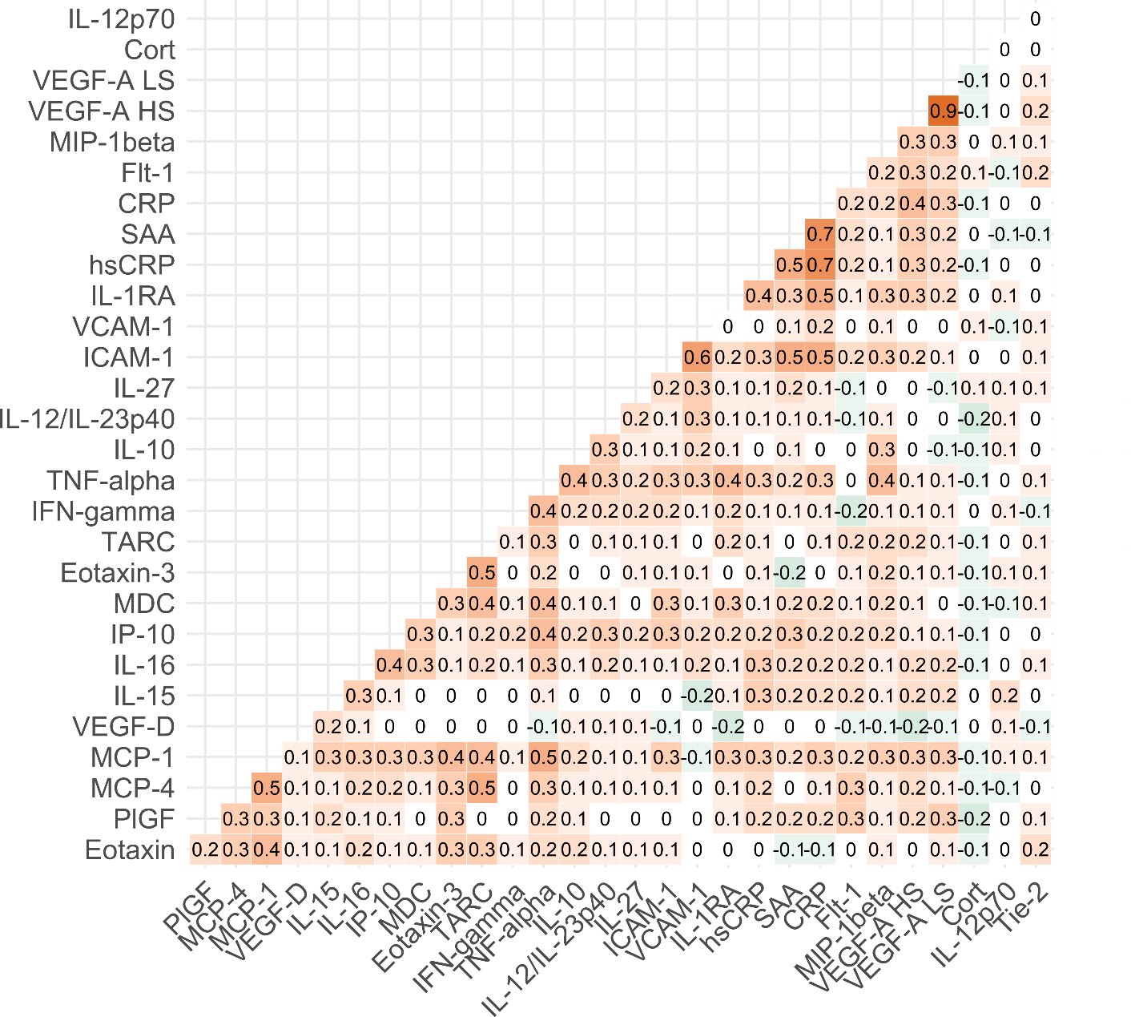

References
Beck, A. T., Steer, R. A., & Brown, G. (1996). Beck depression inventory–II. Psychological Assessment. https://doi.org/10.1037/t00742-000
Kopf-Beck, J., Zimmermann, P., Egli, S., Rein, M., Kappelmann, N., Fietz, J., … Keck, M. E. (2020). Schema therapy versus cognitive behavioral therapy versus individual supportive therapy for depression in an inpatient and day clinic setting: study protocol of the OPTIMA-RCT. BMC Psychiatry, 20(1), 506. https://doi.org/10.1186/s12888-020-02880-x
Montgomery, S. A., & Asberg, M. (1979). A new depression scale designed to be sensitive to change. The British Journal of Psychiatry, 134(4), 382–389. https://doi.org/10.1192/bjp.134.4.382

